Data Acquisition and Manipulation Using SQL Certification Training
Course-End Project-2
Air Cargo Analysis
Akansha Chowdhury
A new database was created –
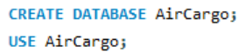
All three datasets where imported under this database AirCargo –
- Customer: Contains the information of customers
- passengers_on_flights: Contains information about the travel details
- ticket_details: Contains information about the ticket details
- routes: Contains information about the route details
The data column “date_of_birth” in Customers, “travel_date” in passenger_on_flight and “p_date” in ticket_details where changed into yyyy-mm-dd format before importing it into the database.
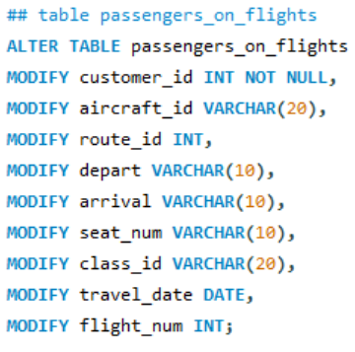
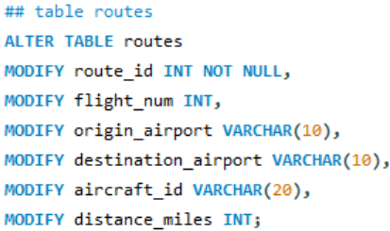
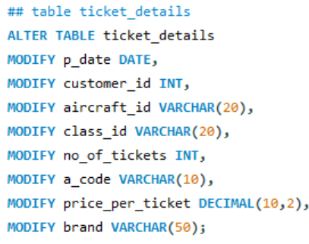
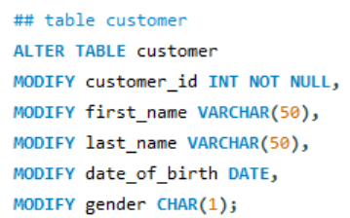
Then the table columns datatypes were changed from “TEXT” to the relevant datatypes

The PRIMARY KEY and FOREING KEY are assigned accordingly –
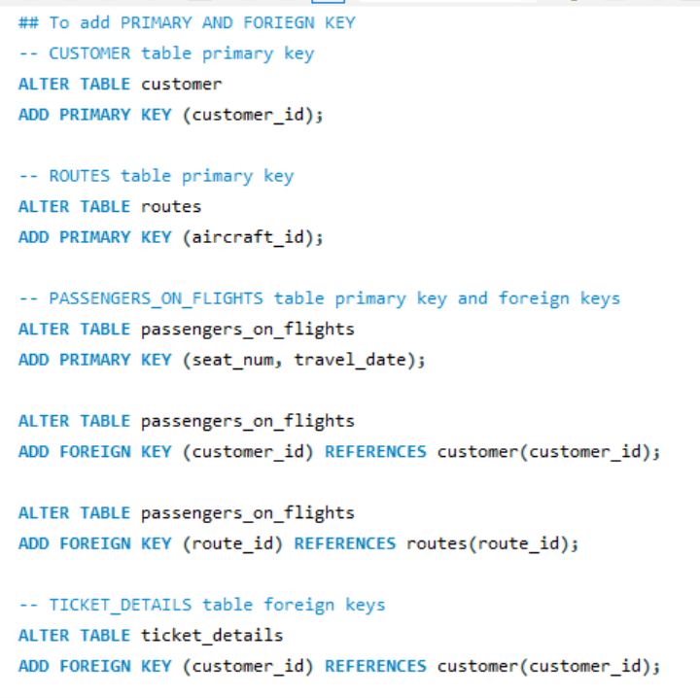
This completes the first task
Task 2 is to create an ER diagram for the given airlines' database.
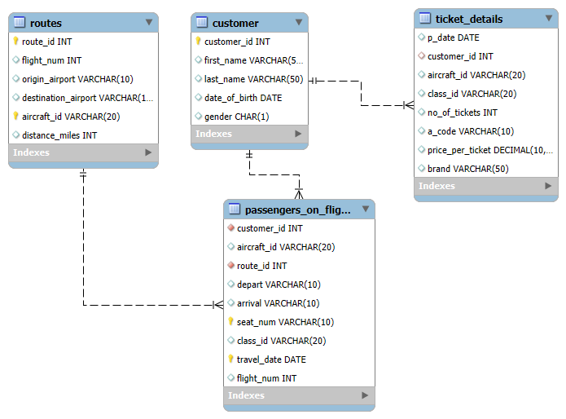
Task 3 to write a query to display all the passengers who have traveled on routes 01 to 25 from the passengers_on_flights table.
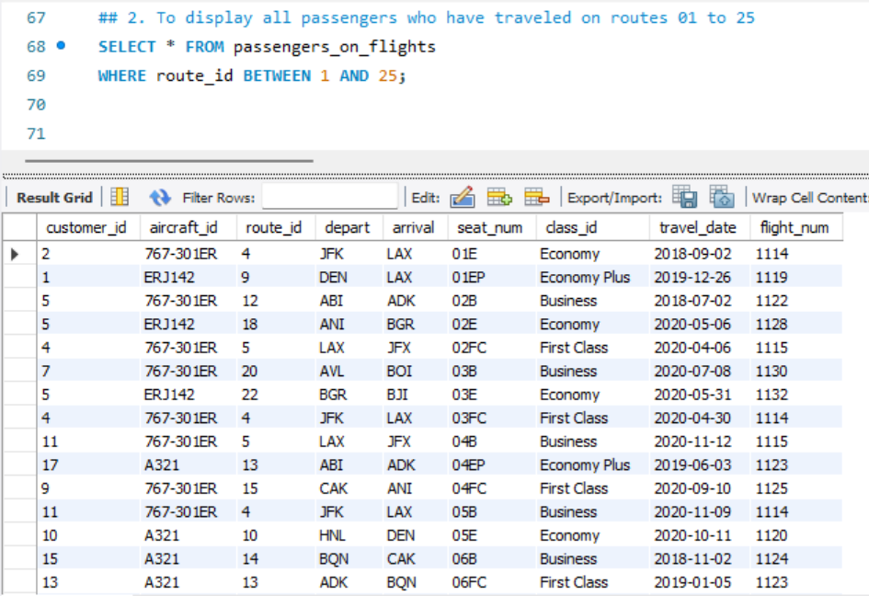
Task 4 is to write a query to identify the number of passengers and total revenue in business class from the ticket_details table.
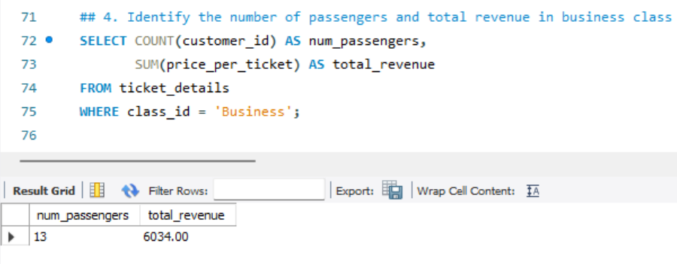

Task 5 is to write a query to display the full name of the customer by extracting the first name and last name from the customer table.
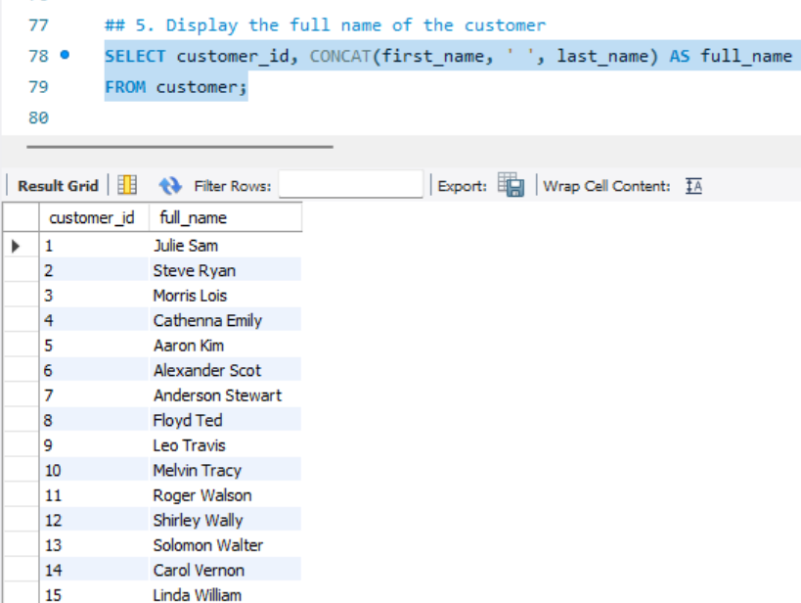
Task 6 is to write a query to extract the customers who have registered and booked a ticket from the customer and ticket_details tables
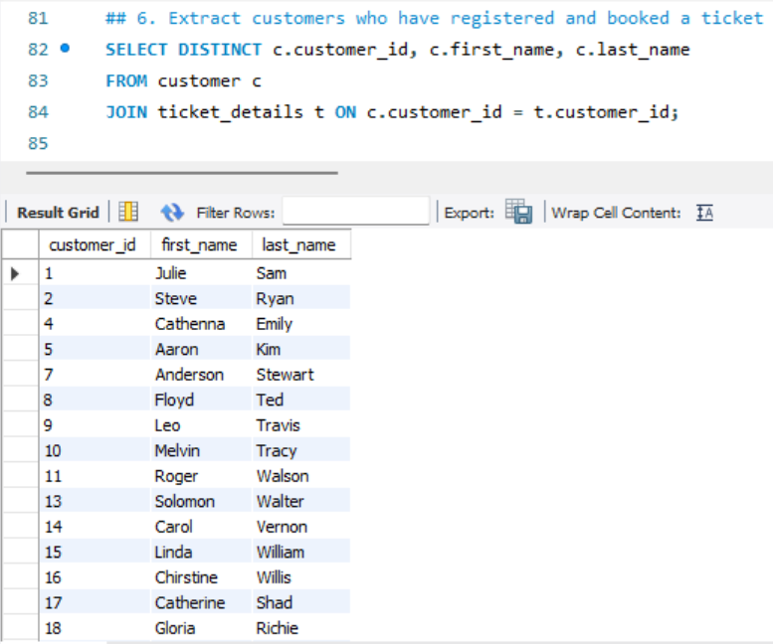

Task 7 is to write a query to identify the customer’s first name and last name based on their customer ID and brand (Emirates) from the ticket_details table.
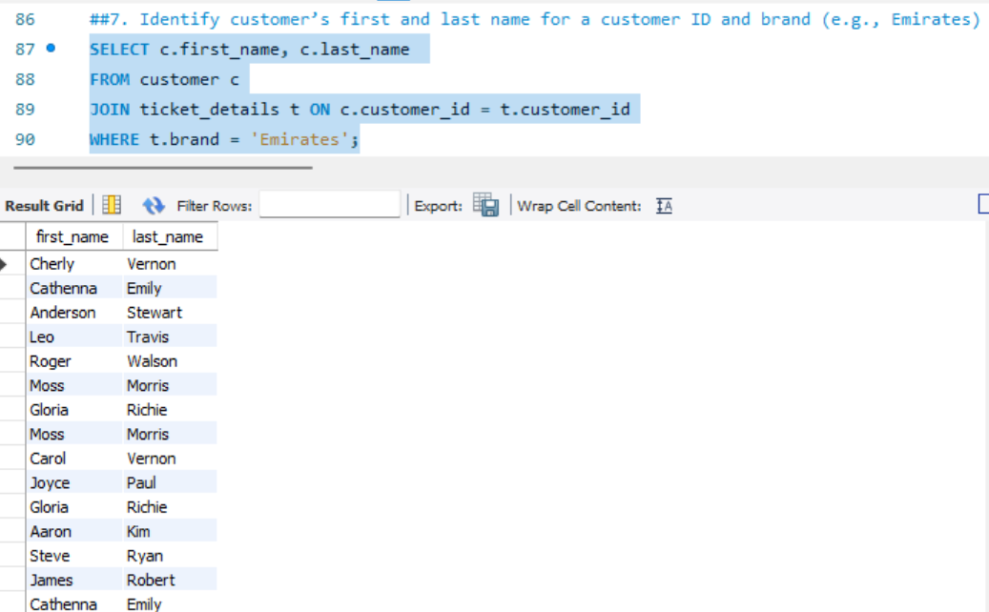
Task 8 is to write a query to identify the customers who have traveled by Economy Plus class using the sub-query on the passengers_on_flights table.
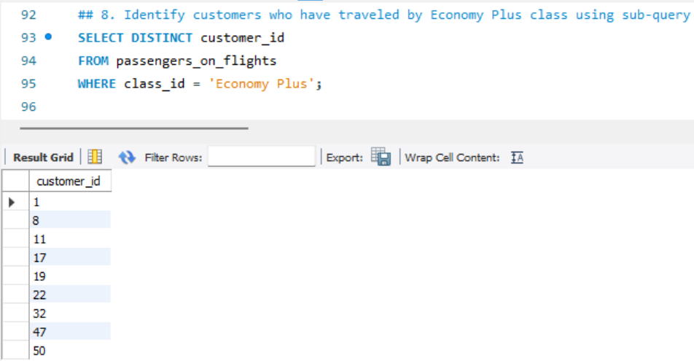
Task 9 is to write a query to determine whether the revenue has crossed 10000 using the IF clause on the ticket_details table.
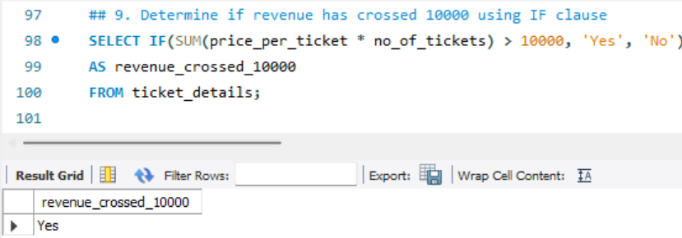

Task 10 is to write a query to create and grant access to a new user to perform database operations.
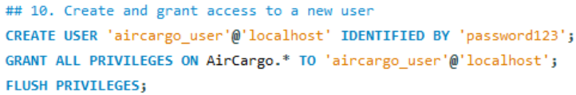
Task 11 is to write a query to find the maximum ticket price for each class using window functions on the ticket_details table.
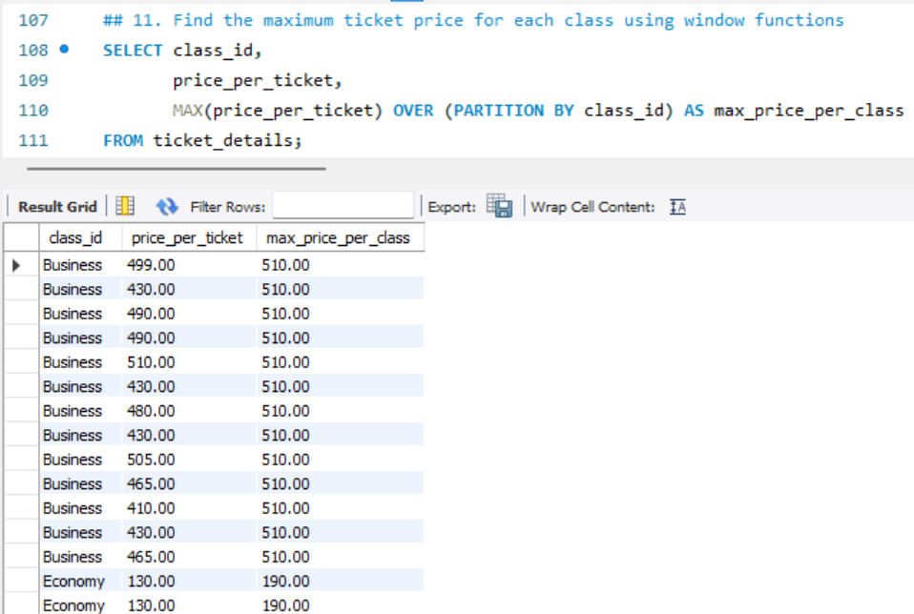
Task 12 is to write a query to extract the passengers whose route ID is 4 by improving the speed and performance of the passengers_on_flights table using the index.
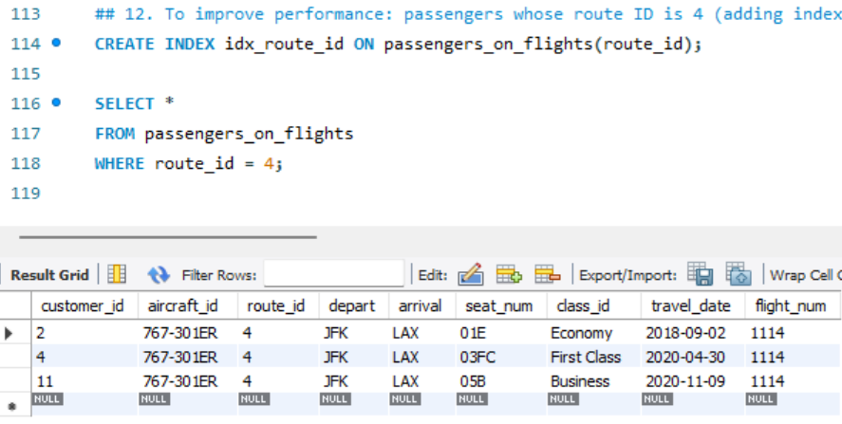

Task 13 is to for route ID 4, write a query to view the execution plan of the passengers_on_flights table.
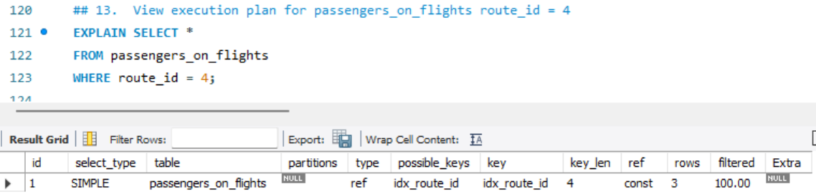
Task 14 is to write a query to calculate the total price of all tickets booked by a customer across different aircraft IDs using the rollup function.
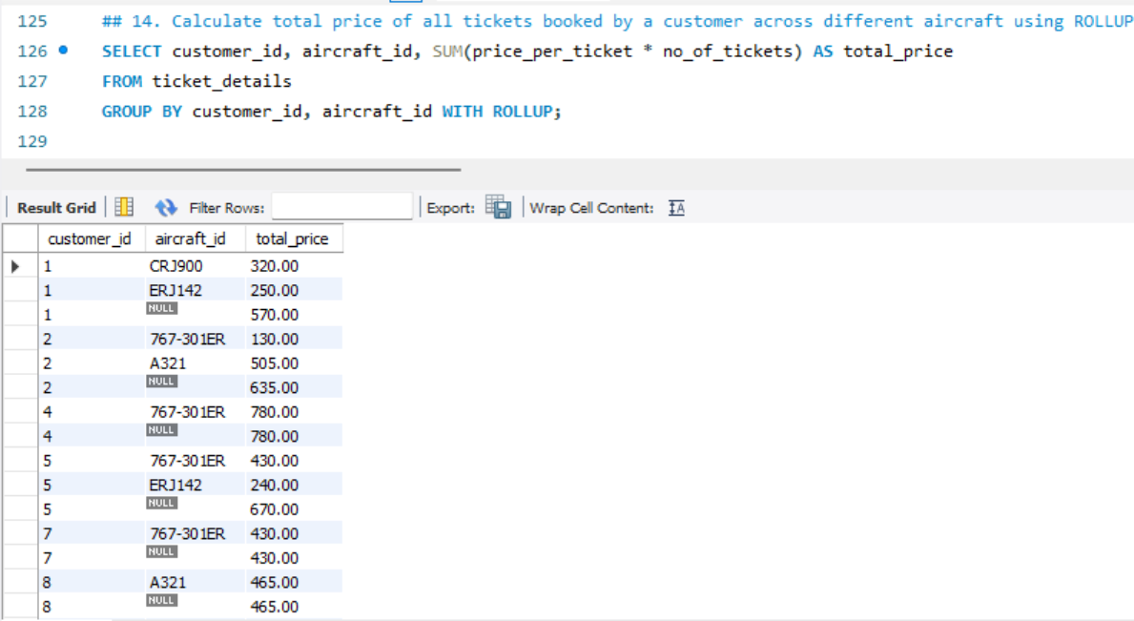
Task 15 is to write a query to create a view with only business class customers and the airline brand.
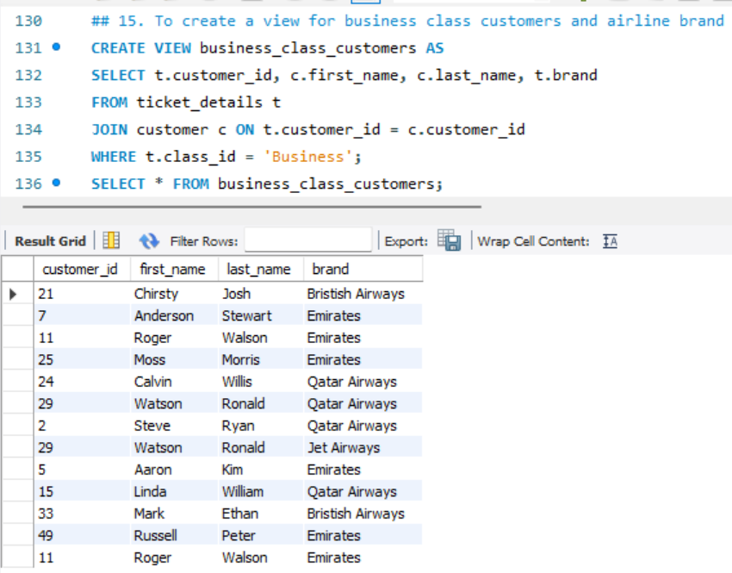
Task 16 is to write a query to create a stored procedure that extracts all the details from the routes table where the traveled distance is more than 2000 miles.
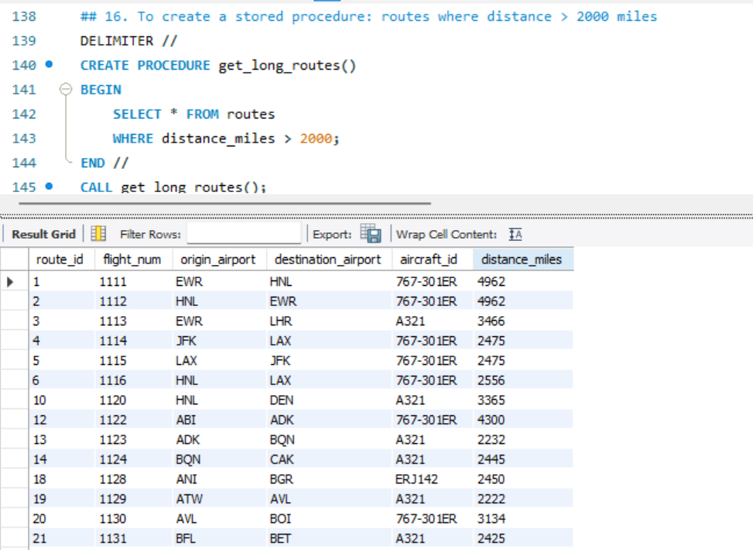
Task 17 is to use GROUP BY, determine the total number of tickets purchased by each customer and the total price paid.
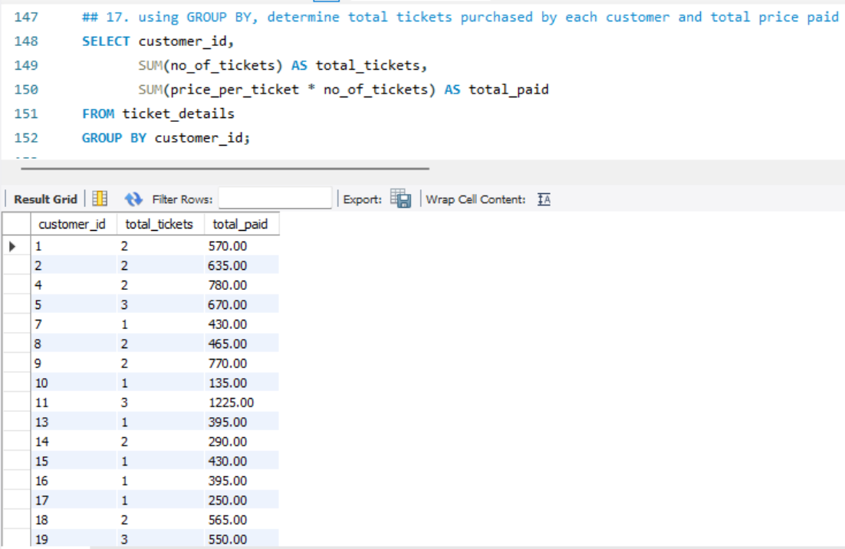

Task 18 is to calculate the average number of passengers per flight route.
